Since GitHub is being used for as the repository for this project’s source code, its built-in defect tracking tool will be used for the purpose of tracking the defects related to this project. It automatically alerts the members involved in the project when new defects are assigned. The screenshot below shows a view of the defect tracker with three sample defects filed.
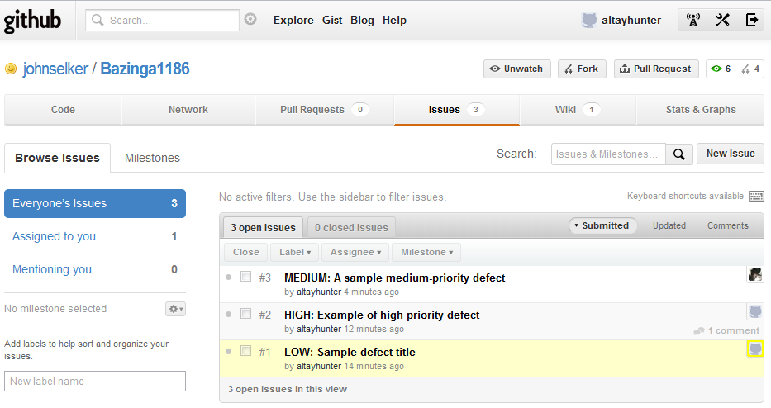
All defects must be filed with a priority to indicate to others how important fixing the defect is. Three priorities are available: low, medium, and high.
Low priority defects are not important to the final product. Examples include typos in the user interface or comments, violations of the coding standards, or other small issues which have no significant influence on the project.
Medium priority defects have significant influence on the outcome of the project. Problems which cause the program to produce unexpected results, prevent the program from compiling, or cause some other problem. Any defects which do not qualify as low or high priority defects are considered medium priority.
High priority defects must cause the program to crash, to freeze, or to violate a safety-critical requirement.
In addition to a priority, defects must have a title, description, and assignee in order to be filed. The person to whom the defect is assigned will receive a notification alerting him of the defect.
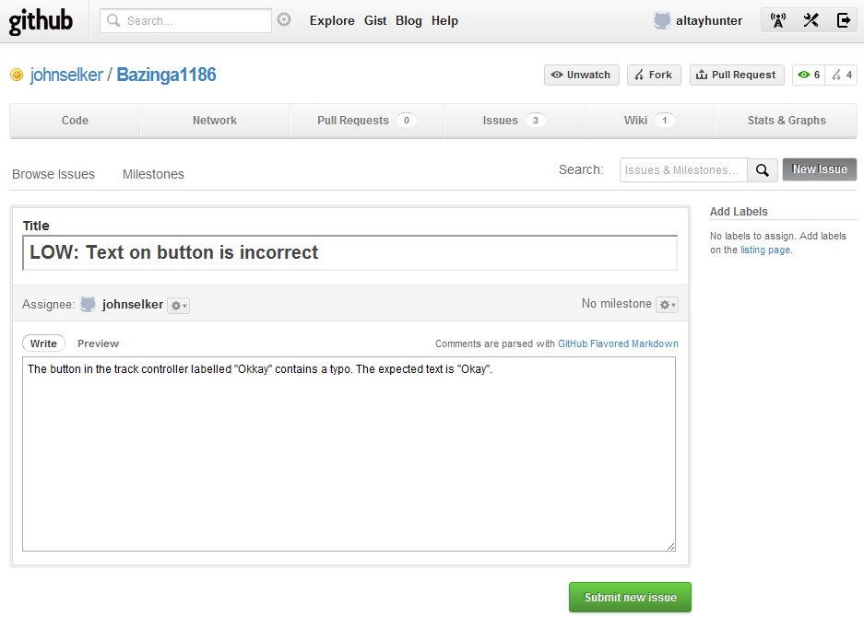
Once the defect has been fixed, the person to whom the defect was assigned will add a comment to indicate it has been fixed and re-assign the defect to the person who filed it. The person who filed the defect is responsible for determining that the defect is indeed fixed and may then close the defect.

